Slide 5
Engineering Standards
Standard | What It Is | How It Will Be Applied
IPC-2221 | PCB Design Standard | Used to guide the design, layout, and fabrication of custom PCBs for remote modules,  ensuring reliability, manufacturability, and electrical integrity.
IEEE 802.3 | Ethernet Standard for Wired LAN Communication | Applied to any wired network interfaces or connections between the gateway and web  interface for stable data transfer.
IEEE 802.11 | Wi-Fi Standard Operating in the 2.4 GHz ISM Band | Implemented for Wi-Fi connectivity in the gateway or modules to enable bi-directional  communication with the web interface.
IEEE 802.15.1 | Bluetooth/BLE Standard for short-range wireless communication | Utilized in remote modules for low-energy, short-range transmission and receiving,  supporting at least one of the required IoT protocols.
IEEE 802.15.4 | Zigbee and Thread Protocol foundation for low-power mesh networking | Applied to enable mesh topology in remote devices, supporting Zigbee or Matter over  Thread for multi-device control and bi-directional communication.
Matter Protocol Specification | Application layer standard for secure, interoperable smart devices | Integrated as an application layer on top of Thread or Zigbee to ensure secure,  interoperable control of remote devices via the web interface.
FCC Title 47 CFR Part 2 | Covers frequency allocation and equipment authorization | Ensured for all transmitting devices to comply with frequency allocation requirements in the 2.4-2.5 GHz ISM band.
FCC Title 47 CFR Part 15 | Regulations for unlicensed RF devices (e.g., Wi-Fi, Bluetooth, Zigbee) | Applied to verify that remote modules and the overall system operate within unlicensed limits without causing interference.
FCC Title 47 CFR Part 18 | Regulations for ISM equipment | Used to ensure compliance for industrial, scientific, and medical equipment operating  in the ISM band.
Slide 9
Demo Idea |  | Smart Watch |  | Entryway |  | Greenhouse
Category | Weight | Score | Weighted Score | Score | Weighted Score | Score | Weighted Score
Power Consumption | 5 | 2 | 10 | 4 | 20 | 4 | 20
Device Interface | 3 | 1 | 3 | 5 | 15 | 3 | 9
Enclosure Size | 5 | 2 | 10 | 4 | 20 | 4 | 20
Peripheral Used | 1 | 5 | 5 | 5 | 5 | 5 | 5
Weight | 2 | 3 | 6 | 4 | 8 | 5 | 10
Creativity | 5 | 5 | 25 | 4 | 20 | 4 | 20
Max Score: | 105 | Total: | 59 | Total: | 88 | Total: | 84

Slide 13
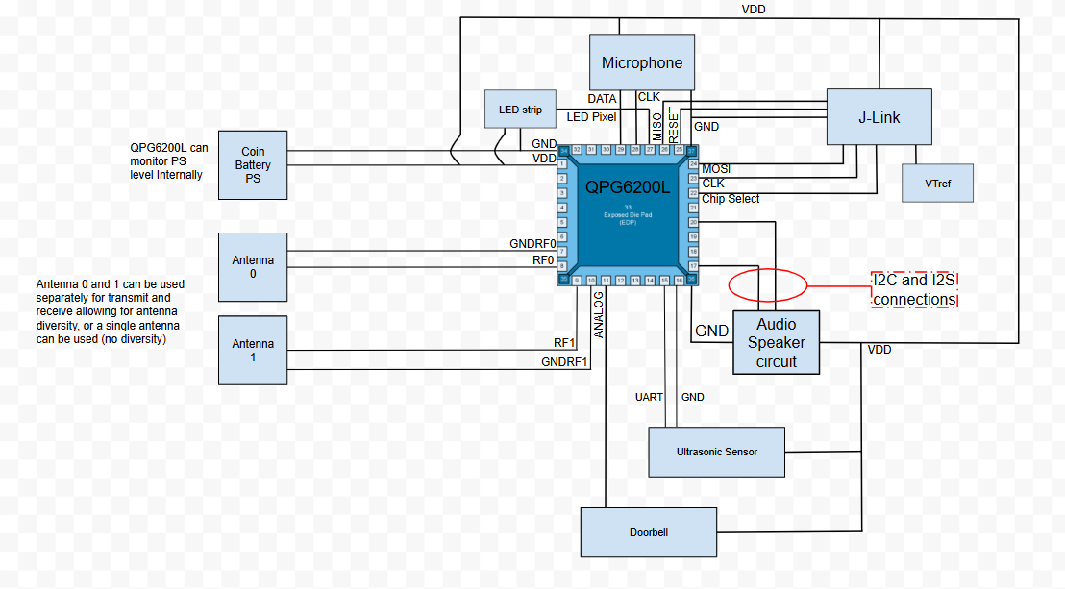

Slide 16

Doorbell |  | RP3502ARED |  | PR144C1900
Section Criteria/Category | Weight (1-5) | Score | Weighted Score | Score | Weighted Score
QPG6200L Peripheral | 5 | 5 | 25 | 5 | 25
Power Supply Required (V) | 1 | 5 | 5 | 5 | 5
Estimated battery life | 5 | 5 | 25 | 5 | 25
Lead Time | 2 | 5 | 10 | 5 | 10
Cost | 3 | 5 | 15 | 4 | 12
Estimated size (3"x3"x3") | 2 | 4 | 8 | 4 | 8
 |  | Total: | 88 | Total: | 85

Slide 20

Microphone |  | 3492 |  | IM69D127
Section Criteria/Category | Weight (1-5) | Score | Weighted Score | Score | Weighted Score
Cost | 1 | 3 | 3 | 5 | 5
Power Supply Required (V) | 3 | 5 | 15 | 5 | 15
Estimate Battery Life | 5 | 3 | 15 | 5 | 25
Lead Time | 2 | 5 | 10 | 5 | 10
Estimated weight (< 0.5 lbs) | 4 | 5 | 20 | 5 | 20
Estimated size (3"x3"x3") | 4 | 2 | 8 | 5 | 20
 |  | Total: | 71 | Total: | 95

Slide 22

Door Lock |  | YRD410-BLE-BSP |  | Tapo D225
Section Criteria/Category | Weight (1-5) | Score | Weighted Score | Score | Weighted Score
QPG6200L Peripheral | 5 | 5 | 25 | 5 | 25
Power Supply Required (V) | 1 | 3 | 3 | 5 | 5
Estimated battery life | 5 | 4 | 20 | 4 | 20
Lead Time | 2 | 5 | 10 | 5 | 10
Cost | 3 | 5 | 15 | 4 | 12
Estimated size (3"x3"x3") | 2 | 4 | 8 | 4 | 8
 |  | Total: | 81 | Total: | 80

Slide 24

Motion detection |  | Ultrasonic Sensor |  | Motion Sensor
Section Criteria/Category | Weight (1-5) | Score | Weighted Score | Score | Weighted Score
Cost | 1 | 3 | 3 | 5 | 5
Power Supply Required (V) | 3 | 5 | 15 | 3 | 9
Estimate Battery Life | 5 | 3 | 15 | 5 | 25
Lead Time | 2 | 5 | 10 | 3 | 6
Estimated weight (< 0.5 lbs) | 4 | 5 | 20 | 5 | 20
Estimated size (3"x3"x3") | 4 | 5 | 20 | 4 | 16
 |  | Total: | 83 | Total: | 81

Slide 27

Antenna |  | MEA-5000-LP-CM |  | MEA-5000-LP-CM
Section Criteria/Category | Weight (1-5) | Score | Weighted Score | Score | Weighted Score
Cost | 1 | 3 | 3 | 5 | 5
Standards | 5 | 5 | 25 | 3 | 15
Lead Time | 2 | 5 | 10 | 2 | 4
Estimated weight (< 0.5 lbs) | 2 | 5 | 10 | 5 | 10
Estimated size (3"x3"x3") | 5 | 4 | 20 | 3 | 15
Frequency Range | 5 | 5 | 25 | 5 | 25
 |  | Total: | 68 | Total: | 49

Slide 30
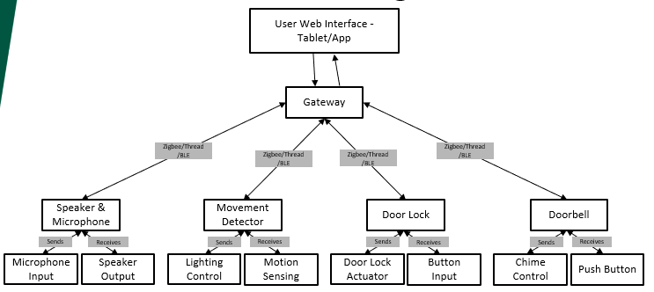

Slide 31

Wireless Protocols |  | Zigbee |  | BLE |  | Thread Over Matter
Section Criteria/Category | Weight | Score | Weighted Score | Score | Weighted Score | Score | Weighted Score
Range | 5 | 4 | 20 | 3 | 15 | 4 | 20
Power Consumption | 1 | 4 | 4 | 5 | 5 | 4 | 4
Data Rate | 3 | 2 | 6 | 4 | 12 | 2 | 6
Scalability (Network Size) | 3 | 5 | 15 | 2 | 6 | 4 | 12
Interoperability | 4 | 3 | 12 | 5 | 20 | 5 | 20
Topology Support | 4 | 5 | 20 | 3 | 12 | 5 | 20
Security | 3 | 4 | 12 | 4 | 12 | 5 | 15
Max Score: | 115 | Total | 89 | Total | 82 | Total | 97

Slide 32

User Display |  | PineTab2 |  | Lenovo Tab M10 Plus 3rd Gen |  | Panasonic Toughbook
Category | Weight | Score | Weighted Score | Score | Weighted Score | Score | Weighted Score
Cost | 4 | 5 | 20 | 5 | 20 | 2 | 8
OS Compatibility | 5 | 5 | 25 | 5 | 25 | 4 | 20
Interactivity | 4 | 4 | 16 | 4 | 16 | 4 | 16
Battery Life | 3 | 4 | 12 | 4 | 12 | 5 | 15
Durability | 2 | 3 | 6 | 3 | 6 | 5 | 10
Ports | 3 | 3 | 9 | 3 | 9 | 5 | 15
Size/Weight | 2 | 4 | 8 | 5 | 10 | 4 | 8
Visual Engagement | 3 | 4 | 12 | 5 | 15 | 4 | 12
Compatibility with Project | 5 | 4 | 20 | 5 | 25 | 4 | 20
Max Score: | 155 | Total: | 128 | Total: | 138 | Total: | 124

Slide 34

User Interface |  | Custom Website |  | ThingsBoard
Category | Weight | Score | Weighted Score | Score | Weighted Score
Development Effort | 5 | 2 | 10 | 5 | 25
Customization | 5 | 5 | 25 | 3 | 15
Cost | 4 | 3 | 12 | 5 | 20
Learning Curve | 4 | 2 | 8 | 4 | 16
Scalability | 3 | 4 | 12 | 5 | 15
Integration with IoT | 5 | 3 | 15 | 5 | 25
Time Spent | 4 | 2 | 8 | 5 | 20
Visual Engagement | 3 | 4 | 12 | 3 | 9
Compatibility | 5 | 4 | 20 | 4 | 20
Max Score: | 190 | Total: | 122 | Total: | 165
Slide 36

Gateway |  | EW840E5N |  | Raspberry Pi 5
Category | Weight | Score | Weighted Score | Score | Weighted Score
Cost | 4 | 4 | 16 | 3 | 12
Protocol Support | 5 | 5 | 25 | 3 | 15
Ease of Setup | 4 | 4 | 16 | 3 | 12
Range | 3 | 5 | 15 | 3 | 9
Power | 2 | 4 | 8 | 4 | 8
Bi-directional Communication | 5 | 5 | 25 | 5 | 25
Mesh Topology Support | 3 | 5 | 15 | 4 | 12
Independence | 3 | 4 | 12 | 5 | 15
Compatibility | 5 | 5 | 25 | 4 | 20
Size/Weight | 2 | 3 | 6 | 4 | 8
Max Score: | 180 | Total: | 163 | Total: | 136

Slide 42
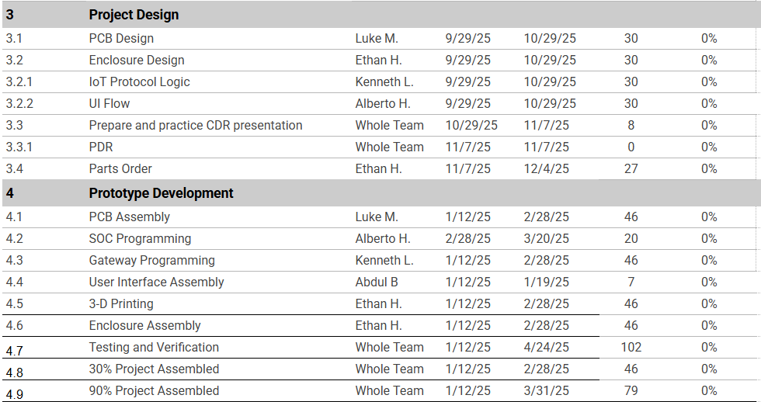

Slide 43: Budget

Category | Item | Quantity | Unit Price | Subtotal | Notes
Mechanical | Plastic Case | 1 | 72.00 | 72.00 | Enclosures for remote devices
Mechanical | PLA Filament | 1 | 24.00 | 24.00 | For 3D printing custom parts
Mechanical | M3 Inserts | 1 | 18.00 | 18.00 | Threaded inserts for assembly
Mechanical | M3 Bolts | 1 | 24.00 | 24.00 | Fasteners for enclosures
Mechanical Subtotal |  |  |  | 138.00
Electrical | Doorbell | 6 | 3.00 | 18.00 | For remote sensing use case
Electrical | Ultrasonic Sensor | 6 | 36.00 | 216.00 | Distance/proximity sensors
Electrical | LED Strip | 1 | 53.00 | 53.00 | For lighting control demo
Electrical | Microphone | 6 | 0.50 | 3.00 | For remote microphone use case
Electrical | Speaker | 2 | 28.00 | 56.00 | Audio output peripherals
Electrical | DAC | 6 | 4.25 | 25.50 | Digital-to-analog converters
Electrical | Audio Amplifier | 6 | 0.60 | 3.60 | For speaker amplification
Electrical | J-Link | 1 | 960.00 | 960.00 | Debugging tool for QPG6200L )
Electrical | J-Link Adapter | 1 | 50.00 | 50.00 | Adapter for J-Link
Electrical | Batteries | 20 | 0.82 | 16.40 | Coin cell for remote devices
Electrical | Battery Holder | 20 | 1.63 | 32.60 | Holders for batteries
Electrical | Door Lock | 1 | 203.99 | 203.99 | For smart lock demo
Electrical | PCB | 1 | 365.00 | 365.00 | Custom PCB for 6 assemblies
Electrical | Antenna | 12 | 13.30 | 159.60 | For RF connectivity
Electrical | QPG6200L | 10 | 4.68 | 46.80 | For RF connectivity
Electrical Subtotal |  |  |  | 2,209.49
Computer | EW840E5N Gateway | 1 | 114.62 | 114.62 | Multi-protocol (BLE/Thread/Zigbee) to WiFi/Ethernet
Computer | PK-LEW840X Programmer | 1 | 36.00 | 36.00 | Required for gateway programming
Computer | Lenovo Tab M10 Plus 3rd Gen | 1 | 228.00 | 228.00 | Display the user sees
Computer Subtotal |  |  |  | 378.62
Grand Total (With 20% Safety Factor) |  |  |  | 2,726.11 | Covers all hardware for IoT demos, enclosures, and control

